Assignment 2: Timings

standard CPU mandelbrot : Mark laptop - 745.987667 msec  
standard CPU mandelbrot : Johri laptop - 507.784997 msec

Mark 1600 \* 1200 : 844.968301 msec  
Johri 1920 \* 1200 : 570.716712 msec

Mark zoom=400 1600 \* 1200 : 3033msec  
Johri zoom=600 1920 \* 1200 : 4121msec

Mark platforms:  
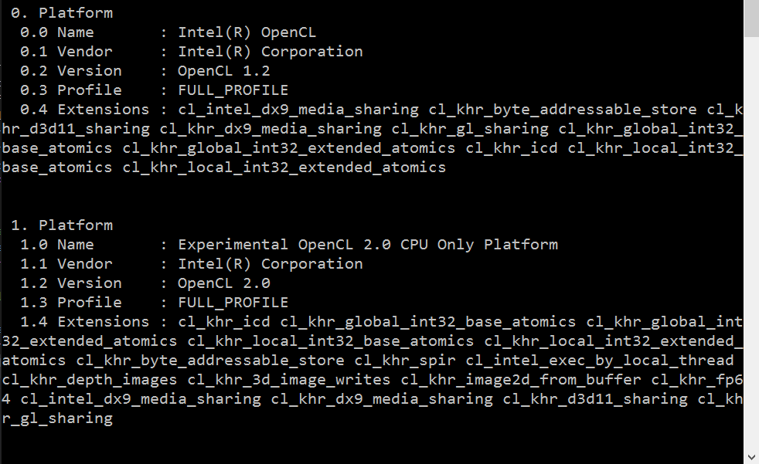  
  
Johri platforms precies hetzelfde  
  
